Project 3 Report CS 475 Jacob Leno

1. All tests were ran on OSU’s os1 server. Load average at time of tests: 0.05, 0.07, 0.14
2. Tables:

|  |  |  |  |  |  |  |  |  |  |  |  |  |  |  |  |  |
| --- | --- | --- | --- | --- | --- | --- | --- | --- | --- | --- | --- | --- | --- | --- | --- | --- |
| **Resulting speedup using NUMPAD padding - Fix # 1** | | | | | | | | | | | | | | | | |
| **NUMPAD** | **0** | **1** | **2** | **3** | **4** | **5** | **6** | **7** | **8** | **9** | **10** | **11** | **12** | **13** | **14** | **15** |
| 1 Thread | 1 | 1 | 1 | 1 | 1 | 1 | 1 | 1 | 1 | 1 | 1 | 1 | 1 | 1 | 1 | 1 |
| 2 Threads | 0.57 | 0.51 | 0.86 | 1.84 | 1.81 | 1.83 | 1.83 | 1.54 | 1.6 | 2.03 | 1.46 | 1.86 | 1.82 | 1.81 | 1.84 | 1.78 |
| 4 Threads | 0.52 | 0.53 | 0.64 | 0.67 | 0.71 | 0.68 | 0.67 | 0.87 | 1.18 | 1.02 | 1.12 | 1.2 | 1.27 | 3.58 | 3.35 | 3.42 |

|  |  |  |  |  |  |  |  |  |  |  |  |  |  |  |  |  |
| --- | --- | --- | --- | --- | --- | --- | --- | --- | --- | --- | --- | --- | --- | --- | --- | --- |
| **Resulting time in seconds using NUMPAD padding - Fix # 1** | | | | | | | | | | | | | | | | |
| **NUMPAD** | **0** | **1** | **2** | **3** | **4** | **5** | **6** | **7** | **8** | **9** | **10** | **11** | **12** | **13** | **14** | **15** |
| 1 Thread | 1.26 | 1.19 | 1.24 | 1.23 | 1.27 | 1.22 | 1.21 | 1.18 | 1.39 | 1.31 | 1.27 | 1.24 | 1.30 | 1.20 | 1.17 | 1.21 |
| 2 Threads | 2.22 | 2.33 | 1.44 | 0.67 | 0.70 | 0.67 | 0.66 | 0.76 | 0.87 | 0.64 | 0.87 | 0.67 | 0.72 | 0.66 | 0.63 | 0.67 |
| 4 Threads | 2.42 | 2.25 | 1.93 | 1.84 | 1.78 | 1.81 | 1.81 | 1.36 | 1.18 | 1.29 | 1.13 | 1.04 | 1.03 | 0.33 | 0.34 | 0.35 |

|  |  |  |
| --- | --- | --- |
| **Resulting speedup using local variable** | | |
| **Threads** | **Speedup** | **Seconds** |
| 1 | 1 | 1.1971 |
| 2 | 1.85 | 0.6479 |
| 4 | 3.97 | 0.3017 |

1. Graph

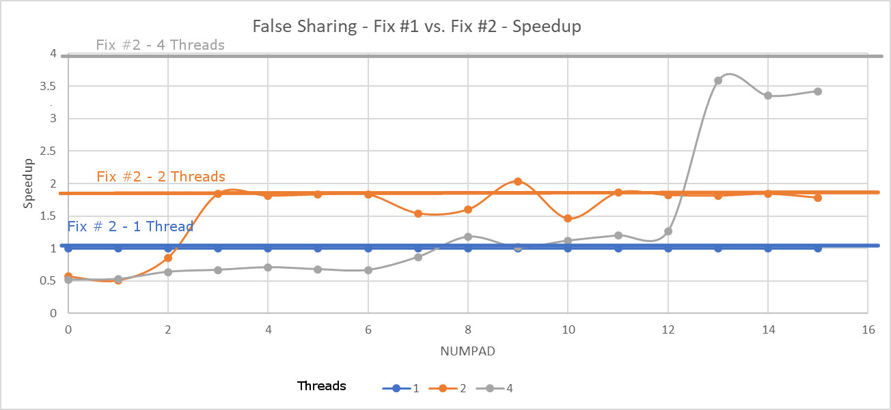

1. For fix 1 the performance increases for 2 threads when the padding changes from 2 to 3. For the same fix the performance increases when the padding increases from 12 to 13. The second fix gives a speedup of 1.85 and 3.97 for 2 and 4 threads respectively
2. It has to do with the way data from memory is loaded into the cache. For fix 1 when the padding is small then all 4 threads are looking at the same cache line. Since each thread must read and write to the same cache line when a value is written the line becomes tagged invalid. When another thread tries to read from that same cache line it can’t so the line must be flushed back to memory and reloaded. This must be done many times when padding values are small since multiple threads are sharing the same area of memory. When the padding increases the values are too large to be stored on a single cache line and are spread out over multiple lines. Doing this decreases the amount of overhead needed and speeds up performance for higher numbers of threads.

Oddly I got different values from what Professor Baily was getting in his lecture. I think it likely has to do with the cache line size of the school’s server. I tried running my tests multiple times and even running them on flip instead of os1 but got the same results.